# Quinte Financial Technologies | FinTech Solutions

**Assignment on**

**EVOLUTION AND RESILIENCE OF**

**U.S. BANKING SYSTEM**

**Under Supervision of:**

**Mr. Mohammad Mozammil**

**Submitted On:**

**7th June, 2024**

**Submitted By:**

**Archita Gupta**

Table of Contents

Evolution of US Banking System 4

Early Banking Era: 4

Free Banking Era: 5

National Banking Era: 6

The Federal Reserve System's Birth: 7

Banking Reforms and Regulations: 8

During Great Depression: 8

Post-World War II Banking Reforms and Developments: 9

Deregulation and Technological Advancements (1980s-2008): 10

Banking Reforms in the Financial Crisis of 2008: 11

Banking Reforms in Response to COVID-19 in the US: 12

Modern Banking System: 14

Recent Reforms in US Banking System: 15

# Evolution of US Banking System

## ****Early Banking Era:****

## **(Late 18th and Early 19th Century)**

In the early years of the United States, during the American Revolutionary War from 1775 to 1783, a group of merchants from Britain ventured to the newly formed nation and founded the Bank of Pennsylvania in 1780. Their objective was to secure funding for the ongoing war efforts. At that time, the country lacked an established currency system, and informal trade practices were commonly employed to facilitate daily financial transactions. Subsequently, on January 4, 1782, the nation's first commercial bank commenced its operations within the United States, *Bank of North America*, with the aim to:

* Manage the national debt
* Establish a uniform national currency
* Facilitate trade by providing credit and stability

It achieved some of its goals but faced political opposition, particularly from those who feared giving too much power to the federal government.

In 1791, U.S. Treasury Secretary Alexander Hamilton created the Bank of the United States, a national bank intended to maintain American taxes and pay off foreign debt (similar goals to first commercial bank). However, President Andrew Jackson closed the bank in 1832 and redirected all bank assets into U.S. state banks as it also faced political opposition and due to distrust in concentrated financial power.

### 

## ****Free Banking Era:****

## **(1836-1863)**

The “Free Banking” Era saw a rapid rise in the number of banks, often with limited regulations. There was no central bank. State-chartered banks issued their own banknotes, leading to a lack of uniformity in currency value. Unregulated lending practices and economic downturns resulted in frequent bank failures, causing financial hardships for citizens. Major highlights:

* **Panic of 1837-** A major financial crisis exemplified the system's vulnerabilities; triggered due to excessive speculation in land, overextension of credit by banks, and President Andrew Jackson's economic policies like the Specie Circular. Almost half of the banks in the U.S. (618 banks) failed between 1837 and 1843 which led to severe economic depression, business failures, unemployment, price declines, and collapse of land values.
* **Investment banking**- Emerged in 1860s when firms like Jay Cooke & Company and Kidder, Peabody & Co. began specializing in raising capital for governments and businesses. These early investment banks underwrote and sold securities to finance major projects like railroads, acting as intermediaries between issuers and investors. They evaluated borrower creditworthiness, structured securities offerings, and facilitated trading. Over time, investment banks expanded into advisory roles for mergers, acquisitions, and corporate finance.
* **Wildcat banking**- Refers to the unregulated and fraudulent practices of some banks during the free banking era before 1863. These "wildcat banks" would often be established in remote areas to avoid redemption demands for their excessively issued banknotes that lacked sufficient reserves. Taking advantage of lax state banking laws and lack of oversight, wildcat banks engaged in rampant speculation, over-issuance of notes, and other risky behaviors that led to widespread instability and bank failures. This highlighted the need for a regulated national banking system, culminating in the National Bank Act of 1863.

## National Banking Era:

## (1863-1912)

The National Banking Acts of 1863 and 1864 established the National Banking System, allowing banks to obtain federal charters from the newly created Office of the Comptroller of the Currency (OCC).

A key feature was the issuance of a uniform national currency, with national banks required to purchase U.S. government bonds and deposit them with the OCC as collateral for issuing national bank notes. This step aimed to provide a more stable and reliable currency compared to the previous era of wildcat banking, where banks issued their own notes with little oversight.

The National Banking System also introduced reserve requirements, capital requirements based on population size, and regular examinations. However, national banks were prohibited from branching across state lines, limiting their geographical diversification. Furthermore, a 10% tax on state bank notes effectively drove them out of circulation, solidifying the national bank notes as the dominant currency.

While the National Banking System brought much-needed regulation and uniformity, it lacked a central banking authority, leaving it vulnerable to financial panics and bank runs. Major highlight:

* Panic of 1907- Another major financial crisis that rocked the United States banking system; triggered by a failed attempt to corner the market on the stock of the United Copper Company, leading to a stock market sell-off and a run on banks (the Knickerbocker Trust Company, one of the largest trusts in New York, experienced devastating bank runs) leading to their failure. The panic led to a severe liquidity crisis, with interest rates spiking, resulting in businesses failing and reduced economic activity.

This shortcoming ultimately led to the establishment of the Federal Reserve System in 1913 as the nation's central banking authority.

## The Federal Reserve System's Birth:

## (1913)

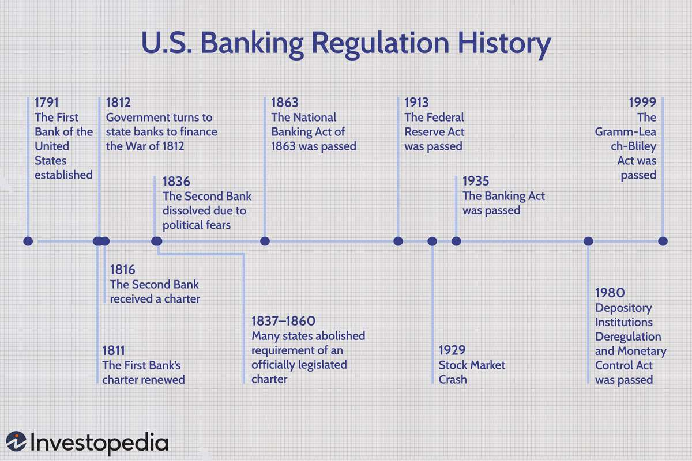The **Federal Reserve System**, established by the Federal Reserve Act of 1913, is the central bank of the United States. Created to address financial instability, the Fed consists of a Board of Governors in Washington, D.C., and twelve regional Federal Reserve Banks. It manages the nation's money supply and interest rates, supervises banks, maintains financial stability, and provides financial services to institutions and the government. The Fed conducts monetary policy through open market operations, setting the discount rate, and regulating reserve requirements, aiming to promote maximum employment, stable prices, and moderate long-term interest rates.

## Banking Reforms and Regulations:

## (1930s-Present)

### During Great Depression:

1. **Banking Act of 1933 (Glass-Steagall Act):**
   * **Separation of Commercial and Investment Banking**: Reduced risks by prohibiting commercial banks from engaging in investment banking.
   * **Federal Deposit Insurance Corporation (FDIC)**: Established deposit insurance to protect depositor funds and prevent bank runs.
   * **Regulation of Interest Rates**: Federal Reserve regulated interest rates on savings accounts to reduce competition among banks.
2. **Banking Act of 1935:**
   * **Strengthening the Federal Reserve**: Centralized monetary policy control within the Board of Governors.
   * **Federal Open Market Committee (FOMC)**: Formalized the FOMC to manage open market operations.
   * • **Securities Act of 1933 and Securities Exchange Act of 1934**
   * **Regulation of Securities Markets**: Increased transparency and reduced fraud; established the Securities and Exchange Commission (SEC).
3. **Emergency Banking Act of 1933:**
   * **Banking Holiday**: Temporarily closed all banks to prevent runs and restore order.
   * **Federal Reserve Support**: Provided federal loans to struggling banks to ensure liquidity and allowed solvent banks to reopen.

### Post-World War II Banking Reforms and Developments:

1. **Consumer Banking Expansion**:
   * Commercial banks expanded consumer banking services.
   * Offered mortgages, auto loans, and personal loans.
2. **Regulatory Reforms**:
   * 1956 Bank Holding Company Act regulated bank holding companies.
   * 1966 Bank Merger Act prevented anti-competitive mergers.
   * 1970 Bank Secrecy Act combated financial crime.
3. **Deregulation**:
   * Depository Institutions Deregulation and Monetary Control Act of 1980 removed interest rate ceilings on deposits.
   * Garn-St. Germain Depository Institutions Act of 1982 deregulated the thrift industry.
4. **Savings and Loan Crisis (1980s)**:

* Deregulation of the thrift industry contributed to risky lending practices and speculative investments, leading to the collapse of hundreds of savings and loan institutions.
* The crisis prompted the creation of the Financial Institutions Reform, Recovery, and Enforcement Act of 1989 (FIRREA), which established the Resolution Trust Corporation (RTC) to liquidate failed thrifts and oversee the restructuring of the industry.

1. **Globalization**:
   * Banks expanded internationally.
   * Facilitated global trade and investment but introduced new risks.

### Deregulation and Technological Advancements (1980s-2008):

1. **Deregulation Initiatives**:
   * **Financial Services Modernization Act (1999)**: Repealed parts of Glass-Steagall Act, allowing commercial banks to engage in investment banking activities.
   * **Gramm-Leach-Bliley Act (1999)**: Further deregulated financial industry, facilitating mergers between commercial banks, investment banks, and insurance companies.
2. **Technological Advancements**:
   * **Internet Banking**: Banks began offering online banking services, allowing customers to conduct transactions and manage accounts remotely.
   * **ATM Networks**: Expanded ATM networks provided greater access to banking services and cash withdrawals.
   * **Electronic Trading**: Adoption of electronic trading platforms transformed financial markets, increasing trading efficiency and liquidity.
3. **Financial Innovations**:
   * **Securitization**: Bundling of loans into securities for sale to investors, leading to increased liquidity and risk dispersion.
   * **Derivatives Market Expansion**: Growth of derivatives markets allowed investors to hedge risks and speculate on price movements.
   * **Credit Default Swaps (CDS)**: Provided insurance against default on debt obligations, but also contributed to systemic risk during the financial crisis.
4. **Globalization of Finance**:
   * Increased cross-border capital flows and integration of financial markets.
   * Expansion of multinational financial institutions and investment opportunities.

### Banking Reforms in the Financial Crisis of 2008:

1. **Emergency Economic Stabilization Act (2008)**:
   * Established Troubled Asset Relief Program (TARP) to purchase troubled assets and inject capital into banks to stabilize the financial system.
2. **Dodd-Frank Wall Street Reform and Consumer Protection Act (2010)**:
   * Implemented comprehensive regulatory reforms to address weaknesses exposed by the crisis and created Consumer Financial Protection Bureau (CFPB) to oversee consumer financial products and services.
   * Introduced Volcker Rule to restrict proprietary trading by banks and limit their exposure to risky investments.
   * Enhanced oversight of systemic risk and established Financial Stability Oversight Council (FSOC) to monitor and address threats to financial stability.
   * Imposed stricter regulations on derivatives trading and credit rating agencies.
3. **Stress Testing and Capital Requirements**:
   * Implemented rigorous stress testing of banks to assess their resilience to adverse economic conditions.
   * Raised capital requirements to ensure banks have sufficient buffers to withstand financial shocks.
4. **Resolution Authority**:
   * Provided authority for orderly liquidation of large, failing financial institutions to prevent systemic disruptions.
   * Aimed to prevent taxpayer-funded bailouts and protect taxpayers from bearing the cost of financial crises.
5. **Regulatory Oversight**:
   * Strengthened oversight of mortgage lending practices to prevent predatory lending and ensure responsible lending standards.
   * Enhanced transparency and accountability in financial markets through improved disclosure requirements and reporting standards.
6. **Systemic Risk Regulation**:
   * Enhanced regulation of systemically important financial institutions (SIFIs) to mitigate risks posed by their size, interconnectedness, and complexity.
   * Required SIFIs to develop plans for orderly resolution in the event of failure.

### Banking Reforms in Response to COVID-19 in the US:

1. **Stimulus Packages**:
   * The CARES Act was a comprehensive economic stimulus package passed by the U.S. Congress in response to the COVID-19 pandemic, providing direct payments to individuals, enhanced unemployment benefits, small business loans, healthcare funding, and aid to state and local governments.
   * Subsequent relief bills provided financial aid to individuals, businesses, and healthcare providers.
2. **Lending Programs**:
   * Establishment of PPP and Main Street Lending Program to support small businesses and maintain employment.
3. **Regulatory Flexibility**:
   * Temporary changes by regulatory agencies allowed flexibility in loan forbearance, capital requirements, and compliance deadlines.
4. **Consumer Protection Measures**:
   * Enforcement actions and mortgage relief programs protected consumers from scams and financial hardship.
5. **Digital Banking Acceleration**:
   * Increased adoption of digital banking and contactless payments to facilitate remote transactions.
6. **Remote Work Policies**:
   * Implementation of remote work policies ensured operational resilience while prioritizing employee safety.
7. **Financial Inclusion Focus**:
   * Efforts to promote access to banking services for underserved communities and support for minority-owned banks and CDFIs.

### Modern Banking System:

1. **Technological Advancements**:
   * Adoption of digital banking, mobile payments, and online financial services.
   * Enhanced customer experience with 24/7 access to banking services and streamlined transactions.
2. **Fintech Integration**:
   * Emergence of fintech companies offering innovative financial products and services.
   * Collaboration between traditional banks and fintech firms to enhance efficiency and expand offerings.
3. **Regulatory Compliance**:
   * Stricter regulatory oversight following the 2008 financial crisis, including implementation of Dodd-Frank Act reforms.
   * Compliance with Know Your Customer (KYC) and Anti-Money Laundering (AML) regulations to prevent financial crime.
4. **Risk Management**:
   * Improved risk management practices, including stress testing and enhanced capital requirements.
   * Focus on cybersecurity to protect against data breaches and cyber threats.
5. **Consumer Protection**:
   * Establishment of Consumer Financial Protection Bureau (CFPB) to oversee consumer financial products and services.
   * Enhanced disclosure requirements and consumer rights protection.

### Recent Reforms in US Banking System:

1. **Rollback of Dodd-Frank Regulations**:
   * Passage of Economic Growth, Regulatory Relief, and Consumer Protection Act (2018) to ease regulatory burden on smaller banks.
   * Relaxation of certain Dodd-Frank Act provisions, such as raising threshold for enhanced prudential standards.
2. **LIBOR Transition**:
   * Transition away from London Interbank Offered Rate (LIBOR) to alternative reference rates, such as Secured Overnight Financing Rate (SOFR), to mitigate risk of benchmark manipulation.
3. **Climate Risk Management**:
   * Increased focus on integrating climate risk considerations into bank risk management practices.
   * Engagement in climate-related disclosures and sustainable finance initiatives.

THANK YOU